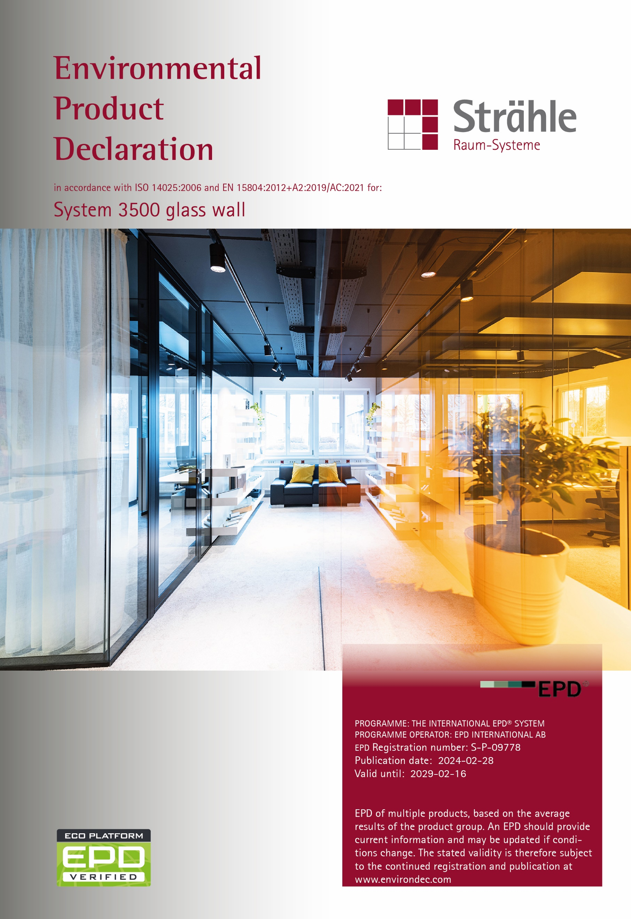

GENERAL INFORMATION
This EPD provides environmental performance indicators for System 3500 – Double-glazed partition wall system from Strähle Raum-Systeme GmbH. This is a cradle-to-gate with modules C1-C4 and D EPD in accordance with the requirements of EN 15804.
The EPD is based on a life cycle assessment (LCA) study which used production data for calendar year 2022 from Strähle Raum-Systeme GmbH's manufacturing facility.
The EPD presents details of the LCA, a description of the product life cycle it covers, values for the environmental indicators specified by EN 15804 and a brief explanation of those results.
The declared unit is one square metre of System 3500 FG double-glazed partition.
 | PROGRAMME INFORMATION
EPD programme: | The International EPD® System
EPD programme operator: | EPD International AB - Box 21060 - SE-10031 Stockholm - Sweden  www.environdec.com - info@environdec.com
Accountability for PCR , LCA and independent third-party verification
EPD based on  Product Category Rules: | The CEN standard EN 15804:2012+A2:2019/AC:2021 serves as the core PCR
EPD based on  Product Category Rules: | The International EPD® System's PCR 2019:14 Construction products, Version 1.3.2 2023-12-08
PCR review conducted by: | The Technical Committee of the International EPD® System;  the Review Panel may be contacted via info@environdec.com
LCA conducted by: | EuGeos srl, www.eugeos.eu
LCA software: | openLCA
Background data from: | ecoinvent v3.8
Third party verification: | Independent third-party verification of this EPD and data,  according to ISO 14025:2006, via  EPD verification by individual verifier
Third party verifier: | Niels Jungbluth, ESU-services Ltd
Approved by: | The International EPD® System
Procedure for data follow-up  during EPD validity: | involves third party verifier:  yes no
The EPD owner has the sole ownership, liability, and responsibility for the EPD.
EPDs within the same product category but registered in different EPD programmes, or not compliant with EN 15804, may not be comparable. For two EPDs to be comparable, they must be based on the same PCR (including the same version number) or be based on fully-aligned PCRs or versions of PCRs; cover products with identical functions, technical performances and use (e.g. identical declared/functional units); have equivalent system boundaries and descriptions of data; apply equivalent data quality requirements, methods of data collection, and allocation methods; apply identical cut-off rules and impact assessment methods (including the same version of characterisation factors); have equivalent content declarations; and be valid at the time of comparison. For further information about comparability, see EN 15804 and ISO 14025.

Company information

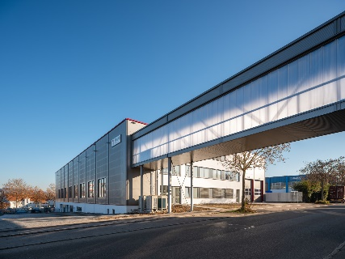
EPD owner

Strähle Raum-Systeme GmbH
Gewerbestraße 6
D - 71332 Waiblingen
Germany
www.straehle.de

Contact
Leonie Peschke
Sustainability manager
l.peschke@straehle.de
Strähle Raum-Systeme GmbH is a leading manufacturer of partition wall, room-in-room and acoustic systems, as well as a pioneer in implementing circular construction in interior design. The flexible wall and room systems are the ideal way to divide up spaces and create relaxation areas, all with specific project requirements in mind. By working with contractors and architects as part of a shared development process, this ensures that the final office solutions are tailored to what users need and how they work.
Established in 1911 as a joinery shop, this family business – currently led by the fourth generation – has grown over the years and now specialises in interior construction using partition wall systems. These Strähle systems are easy to set up and adapt, so layouts can be altered at any time, in line with changing requirements without disrupting day-to-day operations. This means that they tick all the boxes for flexible and long-lasting interior design, especially in terms of the trend towards "new work" and the ongoing reshaping of the workplace.
The product portfolio has grown over the years and now includes new glass wall and door solutions, as well as room-in-room and acoustic systems. Based on this triple-pillar model, Strähle offers high-quality finishing elements for a cohesive, continuous look, all with the same inherent craftsmanship. All of our products are a testament to our commitment to design, functionality and durability. As well as layouts designed with users in mind, our systems play an essential role when it comes to sound insulation, fire protection, acoustics, climate and light, helping to ensure employee safety, concentration and well-being. And to cap it all, Strähle's cradle-to-cradle certified solid and glass wall systems also support the principle of a waste-free circular economy.
As well as designing, developing and manufacturing products, Strähle provides its customers with a comprehensive, specialist package that includes expert technical advice, supplementary acoustic planning services and professional construction. Strähle employs 200 people in its core German market, with manufacturing facilities at its headquarters in Waiblingen near Stuttgart, as well as in Borkheide near Berlin. It sells to other countries in Europe via its subsidiaries in Austria and Switzerland, as well as through system partnerships. In 2022, Strähle recorded sales of around €50 million.
Production sites: Waiblingen, Gewerbestraße 6, D-71332 Waiblingen
Borkheide, Wurzelweg 5, D-14822 Borkheide
Guntramsdorf, Industriestraße 9, AT-2353 Guntramsdorf

PRODUCT INFORMATION

System 3500 – double-glazed partition wall
Flexible and highly transparent partition wall system with double glazing and without vertical posts.



The construction consists of floor and ceiling-mounted profiles that support glazing elements (single-pane or laminated safety glass panes between 10 and 12 mm thick), where the edging uses a special acoustic cruciform joint. The wall thickness is 100 mm. The system can incorporate a variety of door types (solid, aluminium frame, fully glazed, flush-bonded glazing).
System 3500 partitions are classified CPC 4212 under the UN CPC classification system V2.1.

MANUFACTURING
The core elements of Strähle’s partition systems are steel, aluminium and wooden profiles, produced to our specifications.
Steel profiles are powder-coated; aluminium profiles can be powder-coated or anodised. These core profiles are machined and finished at our factories. The partition modules are then assembled with glass or insulating glass units as well as other components and glazing seals that are important for sound insulation.

PACKAGING
Cardboard and plastic films are used to protect individual items during transport, and shipping takes place on reusable frames or racks.

INSTALLATION
Installation is a manual operation also using power tools.

PRODUCT USE & MAINTENANCE
The partitions should be cleaned and inspected regularly.
They are easily re-locatable to reconfigure space in line with changing requirements.

END-OF-LIFE
When the partition systems are removed without further re-installation intended, the main constituent materials should be separated for further treatment or recycling.
The following European Waste Catalogue (EWC) codes below apply to the product or its constituents when removed from the building:
Glass: EWC 17 02 02
Plastic: EWC 17 02 03
Aluminium: EWC 17 04 02
Iron and Steel: EWC 17 04 05
Disposal of materials and components must be carried out safely with due consideration for the prevailing environmental, health & safety regulations and disposal procedures.

RESIDUAL RISKS & EMERGENCIES
There are no residual risks associated with the normal day to day usage of System 3500 partitions, provided they are correctly installed, regularly inspected and maintained.

FURTHER PRODUCT INFORMATION
Detailed product information and datasheets can be found on our website: www.straehle.de

LCA INFORMATION
This section of the EPD records key features of the LCA on which it is based.

DATABASE(S) & LCA SOFTWARE USED
Background data were drawn from ecoinvent 3.8 cut-off model with non-LCIA indicators from GreenDelta's EN 15804 extension; calculations were carried out in openLCA software.

DECLARED UNIT
The declared unit (DU) is one square metre (1m²) of System 3500 partition. The product represented in this EPD is glazed with 2 single panes of 10 mm toughened glass.

TIME REPRESENTATIVENESS
Data collected for the core processes (production) cover a period of 12 months from 01/01/2022 – 31/12/2022.

GEOGRAPHICAL SCOPE
Module A3 is modelled for Germany; the location of manufacture is Waiblingen.
Modelling of the first tier of the supply chain reflects the locations of suppliers, in the European region. Modelling of the supply of basic commodities reflects the global nature of their production.
End-of-life modules are modelled for average European conditions.

CONTENT informATION
Components / materials | Weight;  kg | Post-consumer material;  weight % | Biogenic material;  weight % | Biogenic material;  kg C/DU
Glass | 49 | assumed 4.5 | 0 | 0
Aluminium | 1 | 4.5 | 0 | 0
Polymers | <1 | assumed 0 | assumed 0 | 0
Steel | <1 | 20 | 0 | 0
TOTAL | 51 | 0.1 | 0 | 0

Packaging materials * | Weight;  kg | Weight;  % vs product | Weight  biogenic carbon  kg C/DU
Plastic | <0.05 | <1 | 0
Cardboard | 0.1 | <1 | 0.05
TOTAL | 0.1 | <1 | 0.05
* Quantities of packaging are calculated, by allocation of total packaging use across all products
No substances included in the Candidate List of Substances of Very High Concern for authorisation, derived under the REACH Regulations, are present in the partitions, either above the threshold for registration with the European Chemicals Agency or in excess of >1% weight of the product.

REFERENCE SERVICE LIFE
No reference service life is specified in this EPD.

LCA SCOPE
This EPD covers the production stage, transport to site, installation and end-of-life stages (modules A1-A3, C1-C4 and D; see below). The use stage is omitted in this cradle-to-gate with modules C1 – C4 and D EPD. As permitted by EN 15804, modules A1-A3 are declared in aggregated form.

Product stage |  |  | Construction process stage |  | Use stage |  |  |  |  |  |  | End of life stage |  |  |  | Benefits  & loads beyond the system boundaries
Raw material supply | Transport | Manufacturing | Transport to the site | Assembly | Use | Maintenance | Repair | Replacement | Refurbishment | Operational energy use | Operational water use | De-construction demolition | Transport | Waste treatment | Disposal | Reuse- recovery- recycling- potential
Modules declared
X: included in LCA; ND: module not declared; NR: module not relevant
A  1 | A  2 | A  3 | A  4 | A  5 | B1 | B2 | B3 | B4 | B5 | B6 | B7 | C  1 | C  2 | C  3 | C  4 | D
X | X | X | N  D | N  D | N  D | N  D | N  D | N  D | N  D | N  D | N  D | X | X | X | X | X
Geography
GLO | GLO | DE | - | - | - | - | - | - | - | - | - | EUR | EUR | EUR | EUR | -
Specific data used
8% |  |  | - | - | - | - | - | - | - | - | - | - | - | - | - | -
Variation - products
0 |  |  | - | - | - | - | - | - | - | - | - | - | - | - | - | -
Variation - sites
0 |  |  | - | - | - | - | - | - | - | - | - | - | - | - | - | -
Module D provides an estimate of the potential benefits that would accrue to a different product system were the product constituents and recycled wastes identified in data for other life cycle modules actually recycled or recovered at current rates and using current technologies.

SYSTEM BOUNDARIES
Cradle to gate with modules C1–C4 and module D (A1–A3 + C + D).
The system boundary of the EPD is defined using the modular approach set out in EN 15804. As well as the core processes, the system therefore includes production of all raw materials and components from basic resources; transport of those materials at all stages up to the manufacturing facility and transport to site; installation in the building; the production of fuels and energy carriers and their delivery to manufacturing sites; the treatment of all wastes.
Capital equipment in the foreground system is excluded. Non-reusable packaging used to deliver products and / or components to the place of installation is included in the LCA.
The product life cycle covered by this EPD is illustrated below.

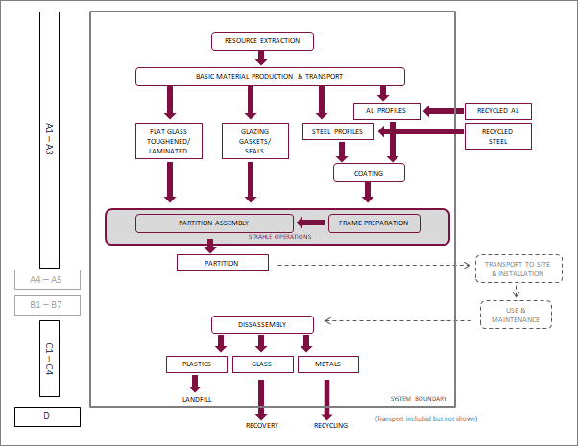

CUT-OFF CRITERIA
The collected data covered all raw materials, consumables and packaging materials; associated transport to manufacturing sites; process energy and water use; direct production wastes; emissions to air and water.
According to EN 15804 and the PCR, flows can be omitted (cut-off) from a core process in the LCA up to a maximum of 1% of the total mass of material inputs or 1% of the total energy content of fuels and energy carriers.
Some polymeric materials used in small quantities and representing <0.01% of total materials used by Strähle in 2022 are omitted from the LCA.

DATA SOURCES & DATA QUALITY
The producer-specific data used in LCA calculations are based on 1 year averaged data and have been updated within the last 5 years. These data were checked to ensure that sufficient materials and water are included within the inputs to account for all products, wastes and emissions.

BACKGROUND DATA
Background (generic) data from the ecoinvent database (v3.8) fulfil the EN 15804 requirement that generic data used in the LCA have been updated within the last 10 years.
The quality of generic data has been reviewed; where necessary, data in the core ecoinvent database have been adjusted to better reflect available information about Strähle’s specific supply chain and about processes that contribute significantly to the LCA results.
Other data were judged fit for purpose. No environmental impact potential stemming from proxy data exceeds 10% for any impact category.

ALLOCATION
In the background data, the ecoinvent default allocation is applied to all processes except those in which secondary materials are used, where the "cut-off" allocation is applied. This ensures that secondary materials are free of upstream burdens that arise prior to their reaching the "end of waste" state, in accordance with Section 6.3.4.2 of EN 15804.
Primary data for Strähle's operations are allocated on the basis of total product area.

ASSUMPTIONS & ESTIMATES
Inputs to and outputs from the system are accounted for over a 100-year time period, except for biogienic carbon. Long-term emissions are therefore omitted from the impact assessment part of the LCA, except for biogenic carbon releases from waste disposal to which no time cut-off is applied.
The "primary energy used as material" indicators (PERM; PENRM) are calculated using - as characterisation factors - published values for constituent materials which can yield energy on combustion, where available, and from published calorific values where PEM values are not available.
In this EPD, primary energy in materials is calculated using values of 50MJ/kg non-renewable for polyethylene, 27MJ/kg non-renewable for other polymers, 16MJ/kg and 14MJ/kg renewable for wood materials and cardboard respectively. As a simplification, the contributions to PENRM from resin and glue in plywood and wood-based panels are not calculated.
"Primary energy as fuel" indicators (PENRE, PERE) are calculated as the total primary energy demand minus primary energy used as material.
Electricity used in manufacturing is a mixture of on-site solar generation and grid electricity, modelled as the residual mix for Germany as reported by the Association of Issuing Bodies (AIB 2022). The overall fuel mix for electricity generation is: solar - 11%; nuclear 10.1%; natural gas - 21.5%; oil - 1.4%; coal - 51.2%; coal / blast furnace gas - 4.8%. The overall GWP-GHG result for this electricity is 0.74kgCO₂e/kWh.
All packaging introduced in the production stage is assumed to become waste; because module A5 is omitted, this is included in Module C4.
It is assumed that – because of their size - the products are disassembled in situ rather than transported prior to disassembly as indicated in the default module C scenario for metal windows and doorsets presented in EN 17213:2020. This disassembly of partitions is modelled as using 0.25kWh of electricity and no other inputs, representing the use of hand power tools. The electricity is modelled as European average low voltage supply.
Following EN 17213, 95% of non-glass materials and 30% of glass materials are assumed to be recovered or recycled, with the remainder landfilled. Of the materials recovered or recycled, metals and glass are assumed recycled with all metal parts other than aluminium framework treated as steel; other materials are assumed incinerated with recovery of energy in an incinerator recovering >60% of total energy. For consistency with the system boundary applied for input of recycled material, sorting and pressing of scrap metal, crushing of waste glass and incineration of other materials are included to represent waste treatment as Module C3.
Module C4 then represents disposal of 70% of the glass content and 5% of the non-glass content of the declared unit, along with the non-reusable packaging. The non-glass content is represented as mixed plastic in the LCA. Energy potentially recovered in landfill gas from the decomposition of biogenic packaging material is omitted as a simplification: such material amounts to <1% of the mass of the declared unit.
Parameters applied in module C2 for the transport of materials to treatment or disposal are shown in the table below.

C2 transport scenario parameters | Quantity and unit  (per declared unit)
Fuel type and consumption of  heavy goods vehicle used for road freight | 0.1l/km, diesel
Distance | 50 km
Capacity utilisation (including empty returns) | 10t / 33%
Bulk density of transported products | 2500 kgm⁻³
Volume capacity utilisation factor | 1

In Module D, benefits and loads are calculated for the net quantity of material recycled or recovered.
Architectural glass is assumed to have no recycled content; for metals net recycling is the recycling rate minus any recycled content. Recycled contents quoted by Strähle’s suppliers are used to derive this: for steel, 20%; for aluminium, a weighted average of 39%. For metals and glass, a quality factor of 0.9 is applied.
Energy exported from incineration is included in Module D, with conversion to electrical energy assumed to be 20% efficient and conversion to thermal efficiency 72%. The potential benefits derived from these exports are calculated on the basis that heat generated substitutes for gas-fired heat generation, and electricity generated substitutes for European-average grid electricity.

ENVIRONMENTAL PERFORMANCE INDICATORS
This EPD contains environmental information in the form of quantitative indicator values for a number of parameters, which encompass calculated environmental impact potentials, resource and energy use, waste generation and material and energy outputs from the product system that may be reused, recycled or recovered into other, unspecified product life cycles. These parameters are listed below along with the abbreviations used for them in the tables of indicator values that follow.

ENVIRONMENTAL IMPACTS (EN 15804:2012 + A2:2019)
Global warming potential - fossil fuels | GWP-fossil
Global warming potential - biogenic | GWP-biogenic
Global warming potential - land use and land use change | GWP-luluc
Global warming potential - total | GWP-total
Depletion potential of the stratospheric ozone layer | ODP
Acidification potential, accumulated exceedance | AP
Eutrophication potential - freshwater | EP-freshwater
Eutrophication potential - marine | EP-marine
Eutrophication potential - terrestrial | EP-terrestrial
Photochemical ozone creation potential | POCP
Abiotic depletion potential - non-fossil resources ¹ | ADPE
Abiotic depletion potential - fossil resources ¹ | ADPF
Water (user) deprivation potential ¹ | WDP
ENVIRONMENTAL IMPACTS (ADDITIONAL - EN 15804:2012 + A2:2019)
Global warming potential - biogenic excluded ² | GWP-GHG

RESOURCE USE INDICATORS
Use of renewable primary energy as energy carrier | PERE
Use of renewable primary energy resources as raw material | PERM
Total use of non-renewable primary energy | PERT
Use of renewable primary energy as energy carrier | PENRE
Use of non-renewable primary energy resources  as raw material | PENRM
Total use of non-renewable primary energy resource | PENRT
Use of secondary material | SM
Use of renewable secondary fuels | RSF
Use of non-renewable secondary fuels | NRSF
Net use of fresh water | FW

WASTE PRODUCTION INDICATORS
Hazardous waste disposed | HWD
Non-hazardous waste disposed | NHWD
Radioactive waste disposed | RWD

OUTPUT FLOWS INDICATORS
Components for re-use | CRU
Materials for recycling | MFR
Materials for energy recovery | MER
Exported electrical energy | EEE
Exported thermal energy | EET
1 - Disclaimer: The results of this environmental impact indicator shall be used with care as the uncertainties of these results are high or as there is limited experience with the indicator
2 - The GWP-GHG indicator accounts for all greenhouse gases except biogenic carbon dioxide uptake and emissions and biogenic carbon stored in the product. As such, the indicator is identical to GWP-total except that the CF for biogenic CO₂ is set to zero. This indicator is closely comparable to the GWP indicator originally defined in EN 15804:2012+A1:2013

ENVIRONMENTAL PERFORMANCE INDICATOR RESULTS
Environmental indicator results for the declared modules are shown in the following tables for the declared unit of 1m². These estimated impact results are only relative statements, which do not indicate the endpoints of the impact categories, exceeding threshold values, safety margins and/or risks.
The A1 - A3 modules are shown on an aggregated basis as required by the PCR; the results of modules A1-A3 should not be used without considering the results of module C.

INTERPRETATION
Indicator values obtained for resource depletion (ADPE, ADPF), stratospheric ozone depletion (ODP) and water deprivation (WDP) potential should be used with caution; all are subject to uncertainties in data or method which limit the scope for their use as the basis for comparisons.
Activities upstream in Strähle’s supply networks contribute strongly to the environmental indicator values reported in this EPD. Evaluation of the data available to represent these activities identified various sources of uncertainty which influence those indicator values. The uncertainty associated with the declared values is considered to be at least +/-10% for the climate change category, and is likely higher for other categories.
No untreated wastes leave the modelled system, which includes waste treatment activities as required by EN 15804. The waste indicators HWD, NHWD and TRWD presented in this EPD therefore represent waste flows within the modelled system.
The reporting of Module D shows benefits as negative indicator values.

ENVIRONMENTAL IMPACTS (EN 15804:2012 + A2:2019)
 | UNIT | A1 - A3 | C1 | C2 | C3 | C4 | D
GWP-fossil | kg CO₂-eq | 9.47E+01 | 9.91E-02 | 5.44E-01 | 3.26E-01 | 3.32E-01 | -1.76E+01
GWP-biogenic | kg CO₂-eq | 8.42E-01 | 6.10E-04 | 2.50E-04 | 4.00E-04 | 2.32E-03 | -8.77E-02
GWP-luluc | kg CO₂-eq | 2.98E-01 | 2.30E-04 | 2.50E-04 | 1.30E-04 | 2.90E-04 | -1.35E-01
GWP-total | kg CO₂-eq | 9.58E+01 | 9.99E-02 | 5.45E-01 | 3.26E-01 | 3.35E-01 | -1.78E+01
ODP | kg CFC11-eq | 1.18E-05 | 4.98E-09 | 1.22E-07 | 1.81E-08 | 1.09E-07 | -2.07E-06
AP | mol H⁺ eq | 3.11E-01 | 5.60E-04 | 2.16E-03 | 9.20E-04 | 2.90E-03 | -1.57E-01
EP-freshwater | kg P eq | 2.76E-02 | 9.98E-05 | 4.08E-05 | 5.36E-05 | 3.27E-05 | -4.46E-03
EP-marine | kg N eq | 4.76E-02 | 9.39E-05 | 6.30E-04 | 2.60E-04 | 1.22E-03 | -2.26E-02
EP-terrestrial | mol N eq | 5.93E-01 | 8.30E-04 | 6.88E-03 | 2.80E-03 | 1.12E-02 | -2.42E-01
POCP | kg NMVOC | 1.64E-01 | 2.30E-04 | 2.11E-03 | 7.80E-04 | 3.22E-03 | -6.97E-02
ADPE | kg Sb-eq | 5.80E-04 | 9.17E-07 | 2.47E-06 | 4.31E-06 | 1.04E-06 | 4.52E-05
ADPF | MJ NCV* | 1.33E+03 | 2.28E+00 | 8.33E+00 | 1.98E+00 | 8.26E+00 | -2.70E+02
WDP | m³ | 6.24E+01 | 7.06E-02 | 4.14E-02 | 7.01E-02 | 3.74E-01 | -9.09E+00
* NCV: Net Calorific Value

ENVIRONMENTAL IMPACT (ADDITIONAL - EN 15804:2012 + A2:2019)
 | UNIT | A1 - A3 | C1 | C2 | C3 | C4 | D
GWP-GHG | kg CO₂-eq | 9.51E+01 | 9.98E-02 | 5.44E-01 | 3.26E-01 | 3.34E-01 | -1.78E+01

RESOURCE USE INDICATORS
 | UNIT | A1 - A3 | C1 | C2 | C3 | C4 | D
PERE | MJ NCV | 1.31E+02 | 4.21E-01 | 1.37E-01 | 1.83E-01 | 9.26E-02 | -5.38E+01
PERM | MJ NCV | 1.76E+00 | 0.00E+00 | 0.00E+00 | 0.00E+00 | 0.00E+00 | 0.00E+00
PERT | MJ NCV | 1.32E+02 | 4.21E-01 | 1.37E-01 | 1.83E-01 | 9.26E-02 | -5.38E+01
PENRE | MJ NCV | 1.32E+03 | 2.28E+00 | 8.33E+00 | 1.98E+00 | 8.26E+00 | -2.70E+02
PENRM | MJ NCV | 5.85E+00 | 0.00E+00 | 0.00E+00 | 0.00E+00 | 0.00E+00 | 0.00E+00
PENRT | MJ NCV | 1.33E+03 | 2.28E+00 | 8.33E+00 | 1.98E+00 | 8.26E+00 | -2.70E+02
SM | kg | 5.60E+00 | 0.00E+00 | 0.00E+00 | 0.00E+00 | 0.00E+00 | -1.08E+01
RSF | MJ NCV | 1.97E+00 | 1.48E-02 | 3.04E-03 | 4.50E-03 | 8.80E-04 | -1.47E-01
NRSF | MJ NCV | 0.00E+00 | 0.00E+00 | 0.00E+00 | 0.00E+00 | 0.00E+00 | -2.72E-01
FW | m³ | 1.18E+00 | 1.80E-03 | 1.05E-03 | 1.72E-03 | 9.02E-03 | -2.32E-01

WASTE PRODUCTION INDICATORS
 | UNIT | A1 - A3 | C1 | C2 | C3 | C4 | D
HWD | kg | 1.36E+02 | 4.95E-01 | 2.14E-01 | 2.86E-01 | 1.68E-01 | -2.07E+01
NHWD | kg | 7.26E+00 | 6.22E-03 | 3.40E-01 | 2.70E+00 | 3.48E+01 | -1.02E+00
RWD | kg | 1.12E-01 | 6.20E-04 | 1.80E-04 | 2.00E-04 | 1.10E-04 | -2.02E-02

OUTPUT FLOW INDICATORS
 | UNIT | A1 - A3 | C1 | C2 | C3 | C4 | D
CRU | kg | 0.00E+00 | 0.00E+00 | 0.00E+00 | 0.00E+00 | 0.00E+00 | 0.00E+00
MFR | kg | 3.44E+00 | 2.46E-02 | 8.45E-03 | 8.23E-03 | 3.74E-03 | -2.73E-01
MER | kg | 1.13E-01 | 1.40E-04 | 2.21E-03 | 7.20E-04 | 2.23E-03 | -2.57E-02
EEE | MJ NCV | 0.00E+00 | 0.00E+00 | 0.00E+00 | 0.00E+00 | 0.00E+00 | 0.00E+00
EET | MJ NCV | 0.00E+00 | 0.00E+00 | 0.00E+00 | 0.00E+00 | 0.00E+00 | 0.00E+00

ADDITIONAL ENVIRONMENTAL INFORMATION

ENVIRONMENTAL IMPACTS (EN 15804+A1:2013)
For information, indicator values calculated using the methods prescribed in the earlier version of EN 15804 (EN 15804+A1:2013) are provided in the table below for the declared unit of 1m² of partition; A1 - A3 are shown on an aggregated basis.

ENVIRONMENTAL IMPACT INDICATORS  EN 15804:2012 + A1:2013 |  | UNIT | A1 - A3 | C1 | C2 | C3 | C4 | D
Global warming potential | GWP | kg CO₂-eq | 9.33E+01 | 9.75E-02 | 5.39E-01 | 3.24E-01 | 3.24E-01 | -1.74E+01
Depletion potential  of the stratospheric ozone layer | ODP | kg CFC11-eq | 1.18E-05 | 4.98E-09 | 1.22E-07 | 1.81E-08 | 1.09E-07 | -2.07E-06
Acidification potential of land and water | AP | kg SO₂-eq | 2.69E-01 | 5.00E-04 | 1.71E-03 | 2.49E-03 | 2.23E-03 | -1.37E-01
Eutrophication potential | EP | kg PO₄³⁻-eq | 1.09E-01 | 3.40E-04 | 3.80E-04 | 2.80E-04 | 9.40E-04 | -2.30E-02
Formation potential of tropospheric ozone photochemical oxidants | POCP | kg ethene-eq | 1.79E-02 | 1.94E-05 | 7.11E-05 | 2.69E-05 | 7.64E-05 | -6.77E-03
Abiotic depletion potential  for non-fossil resources | ADPE | kg Sb-eq | 5.80E-04 | 9.17E-07 | 2.47E-06 | 4.31E-06 | 1.04E-06 | 4.52E-05
Abiotic depletion potential  for fossil resources | ADPF | MJ | 1.33E+03 | 2.28E+00 | 8.33E+00 | 1.98E+00 | 8.26E+00 | -2.70E+02

REFERENCES
Association of Issuing Bodies, 2022 - European Residual Mixes 2021, Version 1.0, 2022-05-31
ecoinvent database (v3.8) - www.ecoinvent.ch
EN 15804:2012+A2:2019/AC:2021 - Sustainability of construction works - Environmental product declarations - Core rules for the product category of construction products - European Committee for Standardisation (CEN) 2022, Brussels
EN 17213:2020 Windows and doors - Environmental Product Declarations - Product category rules for windows and pedestrian doorsets
General Program Instructions for The International EPD® System V4.0 (2021-03-29) - EPD International AB, Sweden
GreenDelta's EN 15804 extension: see https://nexus.openlca.org/database/EN15804%20add-on
ISO 14025:2009-11: Environmental labels and declarations - Type III environmental declarations - Principles and procedures
LCA of Partitions & Doors - Report for Strähle Raum-Systeme (2024) - EuGeos
PCR 2019:14 Construction products, Version 1.3.2 2023-12-08 - EPD International AB, Sweden

GLOSSARY
The International EPD® System (www.environdec.com): a programme for Type III environmental declarations, maintaining a system to verify and register EPD®s as well as keeping a library of EPD®s and PCRs in accordance with ISO 14025.
Life cycle assessment (LCA): LCA studies the environmental aspects and quantifies the potential impacts (positive or negative) of a product (or service) throughout its entire life. ISO standards ISO 14040 and ISO 14044 set out conventions for conducting LCA.
REACH Regulation: REACH is the European Regulation on Registration, Evaluation, Authorisation and Restriction of Chemicals. It entered into force in 2007, replacing the former legislative framework for chemicals in the EU.

www.straehle.de



